

Guidelines for Parish Volunteers
and Lay Employees
(Excerpts re: Duty to Report pp. 12-14)
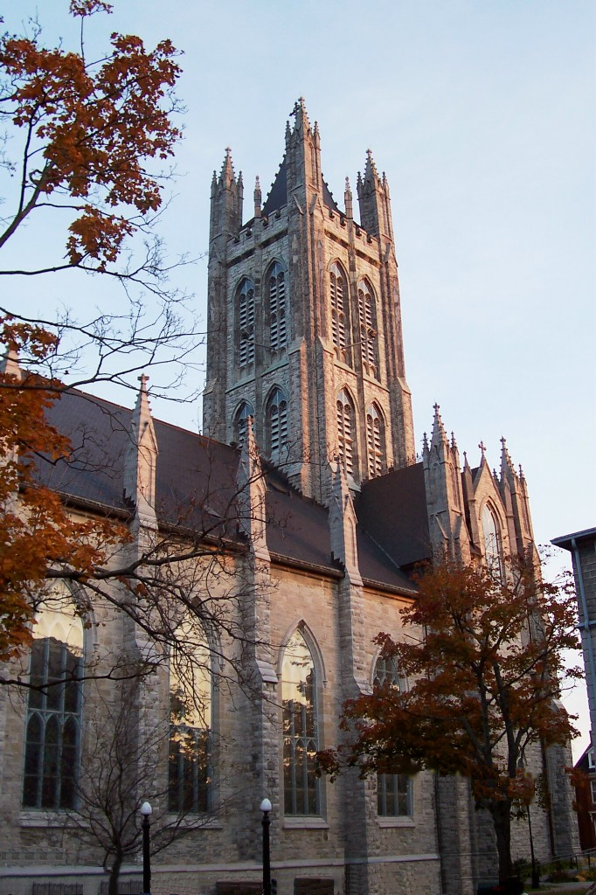

These Guidelines, which are part of the
Screening In Faith Program,
are derived from the
Safe Environment Policy
of the Archdiocese of Kingston

updated November 15, 2016

Pp. 12-14 - Reporting Abuse and/or Inappropriate Conduct of a
Volunteer, Staff or Faith Community Member (Duty to Report)

All Volunteers and Lay Staff are to receive and read the
Guidelines for Parish Volunteers and Lay Employees. All are to be made aware of this Diocesan reporting procedure.

To request copies of the Guidelines for Parish Volunteers and Lay Employees, please contact Mariola Gozdek,
Diocesan Screening Coordinator at
liturgy@romancatholic.kingston.on.ca 613-548-4461

Creating and Sustaining a Safe Environment

The Archdiocese is committed to preventing misconduct by all possible means and to ensuring that all volunteers and lay employees are aware of their duty to report. In order to achieve this goal, information, training, and educational materials about this Archdiocesan policy will be provided on a regular basis.

Obligation to Report

Since the Archdiocese of Kingston holds sacred the sexual integrity of all persons within its sphere of influence and ministry, it is important that all suspicion of sexual misconduct be reported. All cases, however old, should be reported in order that healing may commence and future incidents may be prevented.

  - In the case of the sexual abuse of a minor who is under the age of sixteen:
All volunteers and lay employees of the Archdiocese who suspect an offence, or receive an allegation, concerning a minor who has suffered or may be suffering from sexual abuse, and who is, or appears to be, under the age of 16 years, must comply with the legal obligation to report by informing immediately the Children’s Aid Society (Family and Children’s Services – see Appendix 1). They must also immediately inform the Archbishop’s Delegate, who can be reached by telephone at 613-548-4461, if the alleged perpetrator is a member of the clergy, a religious or lay employee, or a volunteer of the Archdiocese.

  - In the case of sexual misconduct involving minors age sixteen and older:
All of those mentioned above who have reasonable grounds to suspect sexual misconduct or who receive an allegation of sexual misconduct by a member of the clergy, a religious or lay employee, or a volunteer of the Archdiocese, must immediately report it to the Archbishop’s Delegate, who, after consulting legal counsel, will follow the norms of civil law regarding the notification of civil authorities. The Delegate shall also immediately advise the Archbishop.

There is a legal obligation to report suspected abuse of a minor who is a Crown Ward (under the care of a Children’s Aid Society) and who has not yet reached the age of eighteen.

Protection from Liability CFSA (Child and Family Services Act) s.72(7)
If a civil action is brought against a volunteer or lay employee who made a report, that person will be protected, unless he or she acted maliciously or without reasonable grounds for his or her suspicion.

Confidentiality: When to Seek Help or Report Abuse
Confidentiality does not need to be respected in the following situations:

- when the child or youth threatens suicide;
- when the well-being of the volunteer or someone else is threatened;
- when the situation is beyond the volunteer’s experience or expertise.

In the above situations, it is appropriate to seek help and advice from the ministry leader, the pastor, or the Parish Screening Team.

Reporting Abuse

and/or Inappropriate Conduct

Everyone has a responsibility for the welfare of children, seniors, and other vulnerable persons. We also have a responsibility to other volunteers, to our parishes, and to ourselves. If you discover an instance of abuse involving a member of the faith community, you have the responsibility to report it according to the reporting procedures listed below:

Reporting Procedures

- In the case of a child or youth under 16 years of age, there are two steps to follow:

Step 1: Contact the local Children's Aid Society (CAS) and report the abuse, as required under the Ontario Government's Child and Family Services Act (CFSA) Section 72 – Reporting Requirements.

This means that, if a volunteer or lay employee suspects abuse, he or she must report it to the CAS personally and promptly. He or she may ask for assistance but is not to rely on anyone else to make the call.

Step 2: Fill out an incident report according to the instructions outlined in the following section, ‘Documentation of Suspected Abuse and/or Inappropriate Conduct’. Contact the Archbishop’s Delegate at 613-548-4461. Give the Delegate a copy of the incident report you have prepared as soon as possible. The Archbishop’s Delegate will contact/inform all necessary parties and proceed according to current Archdiocesan policies and regulations related to misconduct.

- In situations of abuse or misconduct related to vulnerable persons
over the age of 16:

Contact the Archbishop’s Delegate at 613-548-4461. The Delegate will contact/inform all necessary parties and proceed according to current Archdiocesan policies and regulations related to misconduct.

Documentation of Suspected Abuse and/or Inappropriate Conduct

Document any observations of abuse or inappropriate behaviour (and any related statements or conversations) as soon as possible. Describe the incident or situation and include the date, time, and location the event took place. Include the names of anyone who may have witnessed the event and what actions were taken by you or by them. (i.e. contact with Children’s Aid Society, other parties involved, medical care provided, individuals spoken with, etc.) A sample incident report form is provided on page 14. Keep these documents strictly confidential, and pass them on to the Archbishop’s Delegate as soon as possible.

INCIDENT REPORT FORM

Date: __________________________________________

Name of Person Reporting Incident: ___________________________________________________

Location of Incident: _________________________________________________________________

Parties Involved in Incident: __________________________________________________________

____________________________________________________________________________________

Summary of Incident:

_____________________________________________________________________________________________________________________________________________________________________________________________________________________________________________________________________________________________________________________________________________________________________________________________________________________________________________________________________________________________________________________________________________________________________________________________________________________________________________________________________________________________________________________________________________________________________________________________

Action Taken and/or Follow-up Necessary:

______________________________________________________________________________________________________________________________________________________________________________________________________________________________________________________________________________________________________________________________________________________________________________________________________________________________________________________________________________________________________________________________
__________________________________________________________________________________________________________________________________________________________________________

APPENDIX 1

CONTACT INFORMATION FOR THE ARCHDIOCESE OF KINGSTON AND CHILDREN’S AID SOCIETIES WITHIN THE ARCHDIOCESE

Archdiocese of Kingston
Archbishop’s Office and Pastoral Centre (Archbishop’s Delegate)

390 Palace Road
Kingston, ON K7L 4T3
Tel. (613) 548-4461 Fax: (613) 548-4744

-------------------------------------------------------

Hastings County and Prince Edward County:
Belleville, Marmora-Madoc, Tweed-Stoco, Frankford-Stirling-Batawa, Trenton, Marysville-Read-Deseronto, Flinton-Ardoch, and Picton:

Highland Shores Children’s Aid
363 Dundas St. W.
Belleville, Ontario K8P 1B3
(800) 267-0570 or (613) 962-9291
www.highlandshorescas.org

-------------------------------------------------------

Frontenac County, City of Kingston, and Lennox and Addington County:
Kingston, Kingston-Mills, Bedford-Sharbot Lake, Eastern part of Railton (Sydenham area), East of Desoronto, Amherstview-Bath, Railton (western part)-Odessa, Enterprise-Centreville-Erinsville:

Family and Children’s Services of Frontenac, Lennox and Addington
817 Division Street
Kingston, Ontario
K7R 3Y5
(613) 545-3227
www.facsfla.ca

-------------------------------------------------------
Lanark County and Leeds and Grenville County:
Perth, Smiths Falls, Carleton Place, Lanark-Stanleyville-Bathurst; Brockville, Prescott-Cardinal, Kemptville, Spencerville-North Augusta, Toledo-Athens, Lansdowne-Rockport, Elgin, Westport

Family and Children’s Services of Lanark, Leeds and Grenville
438 Laurier Blvd.
Brockville, Ontario K6V 6C5
Monday – Sunday (24 hours)
1-855-667-2726
FAX 613-498-2109
(613) 264-9991 (Perth)
www.fcsllg.ca

Ottawa-Carleton Area

The Children's Aid Society of Ottawa
1602 Telesat Court
Ottawa, Ontario K1B 1B1
(613) 747-7800 www.casott.on.ca

-------------------------------------------------------

Stormont, Dundas and Glengarry Counties:
Chesterville-South Mountain, Morrisburg and Iroquois

The Children’s Aid Society of the
United Counties of Stormont, Dundas, and Glengarry
150 Boundary Road
Cornwall, Ontario K6H 6J5
(613) 933-2292 or (866) 939-9915
www.cassdg.ca

___________________________________________________________________

See page 5 for complete guidelines governing confidentiality.

